This are the 10 question topics multiple choice: 1. use case diagram 2. class diagram 3. Secuence diagram/Activity 4. Solid 5. C4 6. DDD 7. GoFDP 8. Agile Requirements (User stories) 9. Data Bases 10. Micro Services
1. Use Case Diagram
What it is
- A UML diagram that models functional behavior of a system from the user’s perspective.
- Shows how actors interact with use cases inside a system boundary.
Core elements
- Actors: external entities (people or systems).
- Use cases: system functionalities (ovals).
- System boundary: separates system from environment.
- Relationships:
  - Include: mandatory reuse of behavior.
  - Extend: optional/conditional behavior.
  - Generalization: inheritance between actors or use cases.
  - Association: communication link actor ↔ use case.
Purpose
- Define system scope.
- Communicate requirements clearly to stakeholders.
- Basis for detailed use case specifications.
Source: SE_03.pdf, pp. 25–31
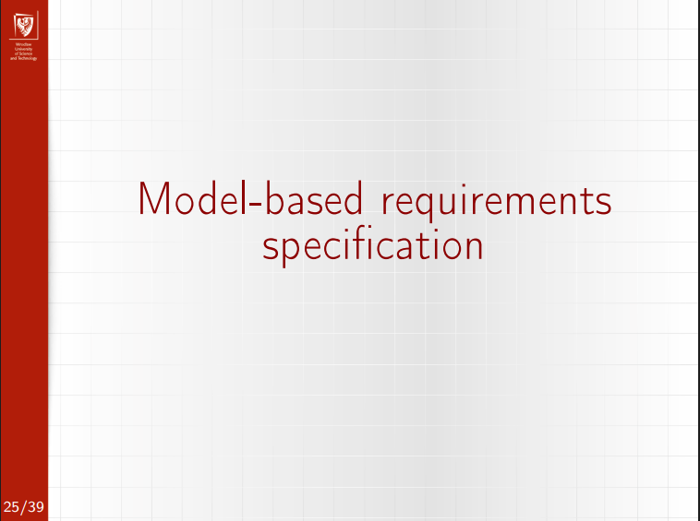
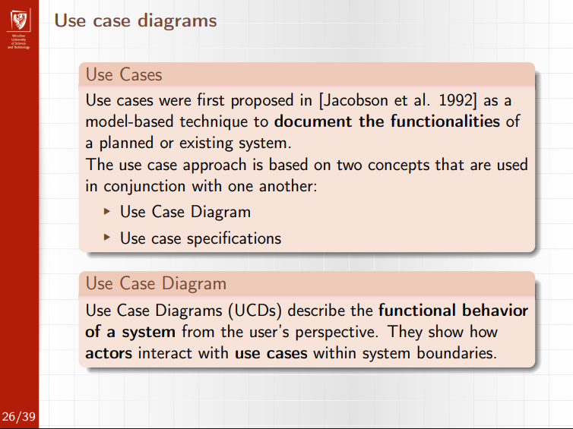
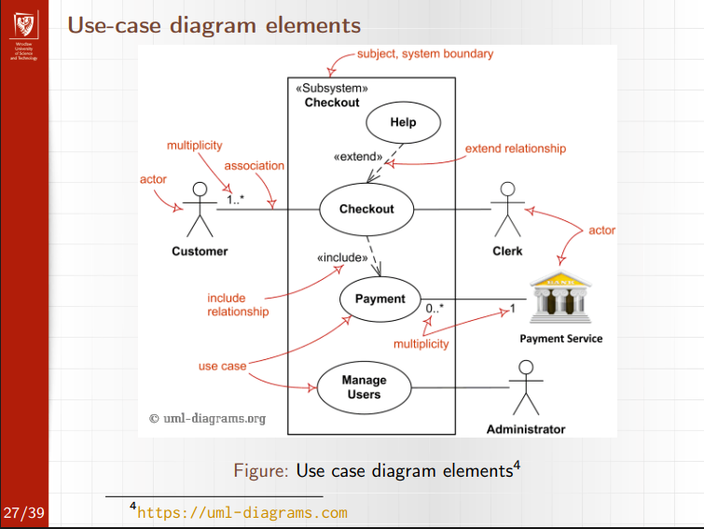
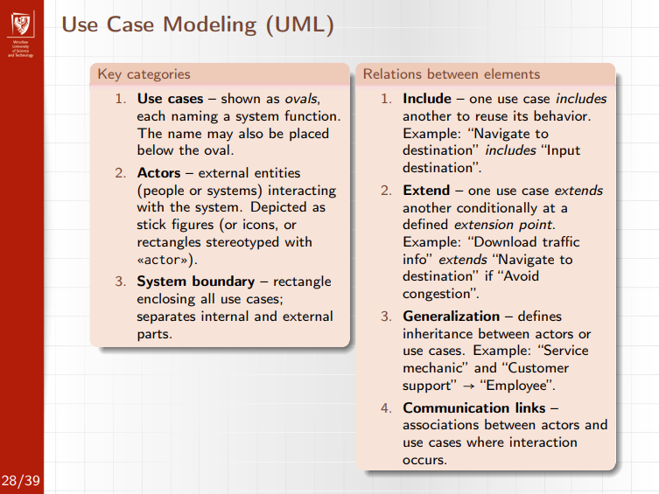
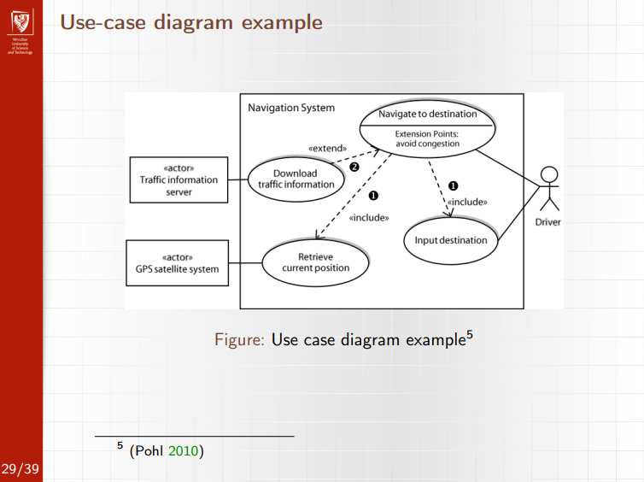
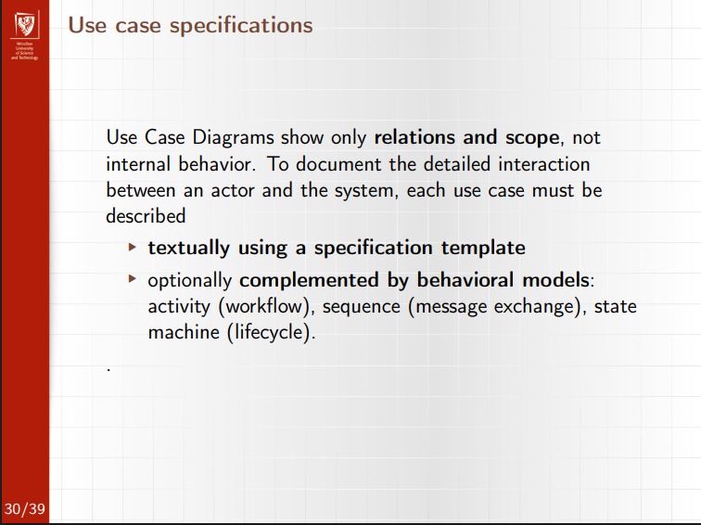
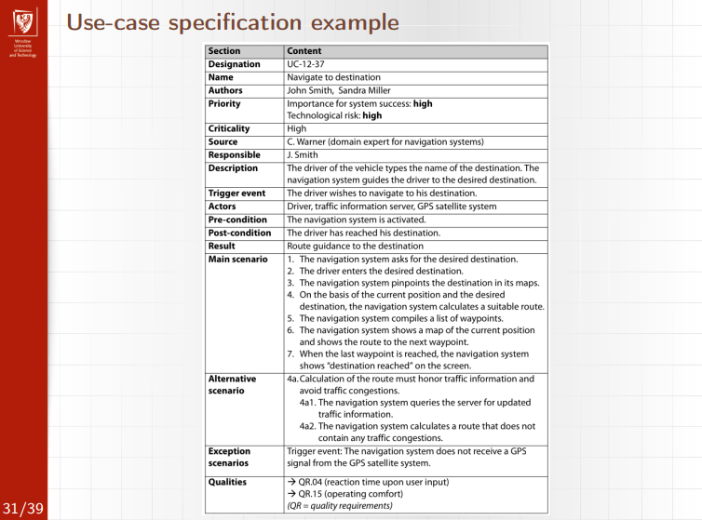

2. Class Diagram
Purpose
- UML structural diagram showing the static structure of a system.
- Models classes, attributes, operations, and relationships.
Core elements
- Class: name, attributes, operations.
- Classifier types: class, interface, enum, data type.
- Visibility: + public, - private, # protected.
- Stereotypes: «entity», «control», etc.
Relationships
- Association: structural link (with roles, navigability, multiplicity).
- Aggregation: weak whole–part (empty diamond).
- Composition: strong ownership, lifecycle dependency (filled diamond).
- Generalization: inheritance (triangle arrow).
- Dependency: usage relationship (dashed arrow).
Multiplicity
- Examples: 1, 0..1, *, 1..*, 2..5
- * = unspecified upper bound (not mathematical infinity).
Uses
- Domain modeling
- OOP code derivation
- Information and subsystem design
Source: SE_06_07.pdf, pp. 17–21
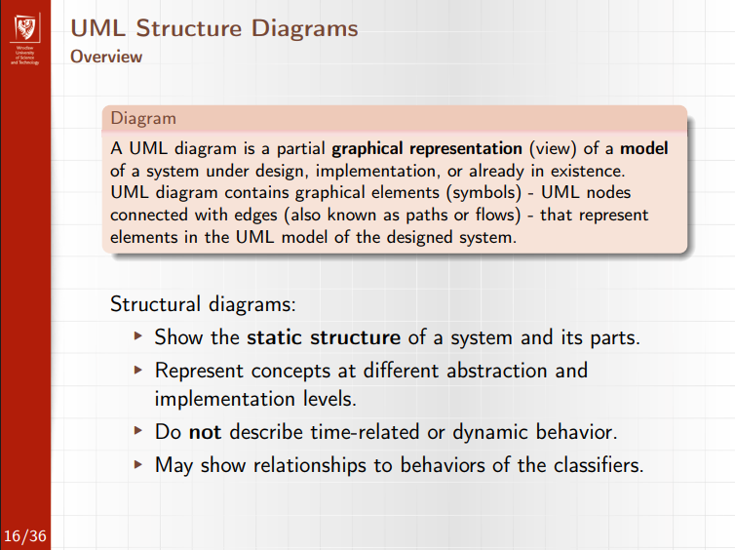
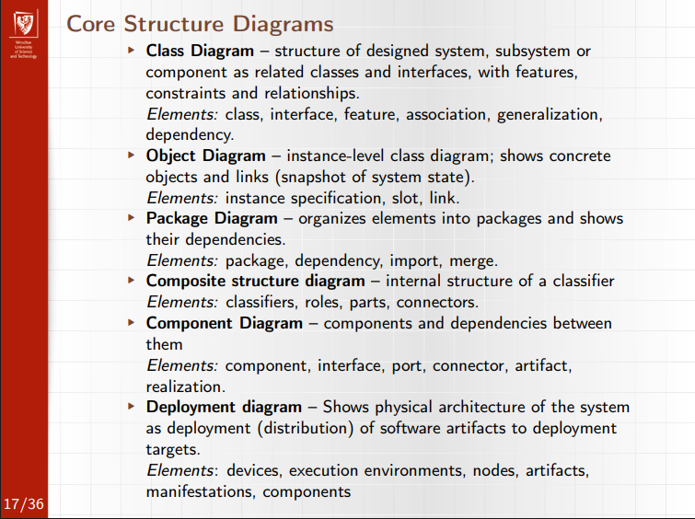
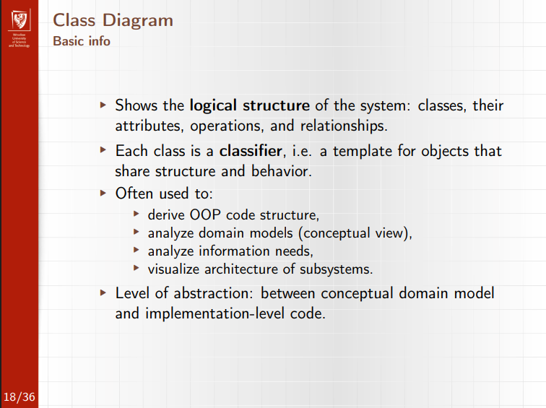
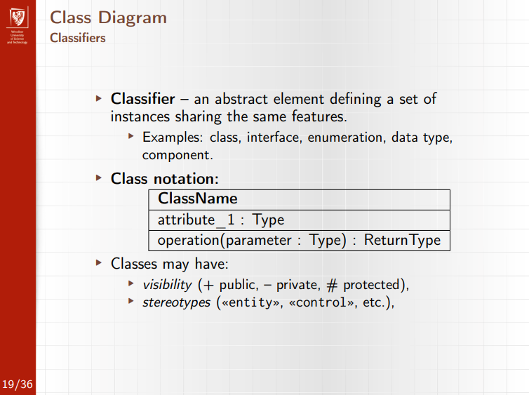
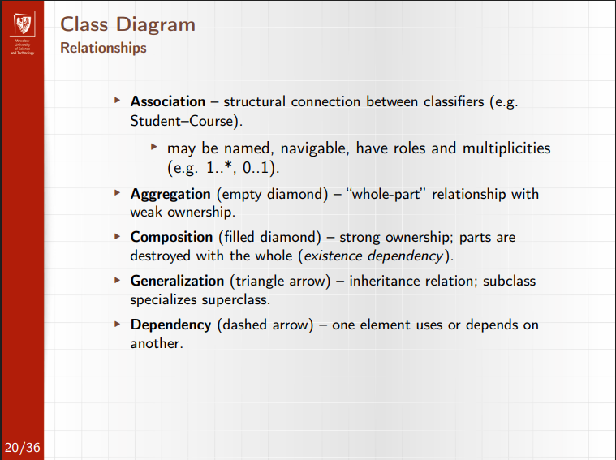
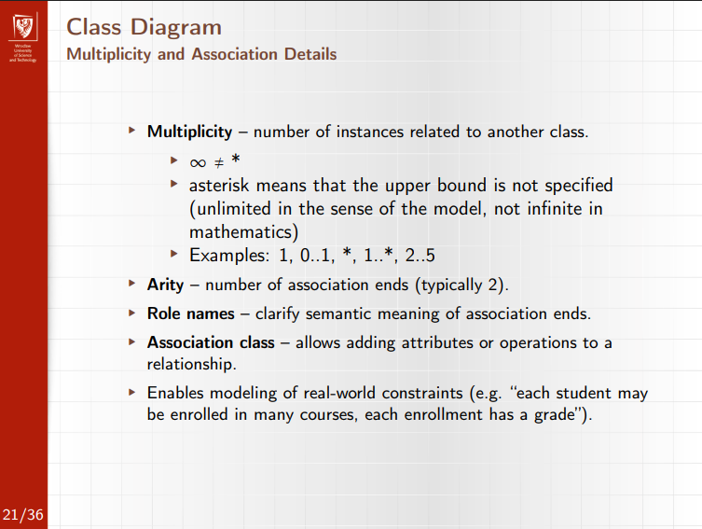
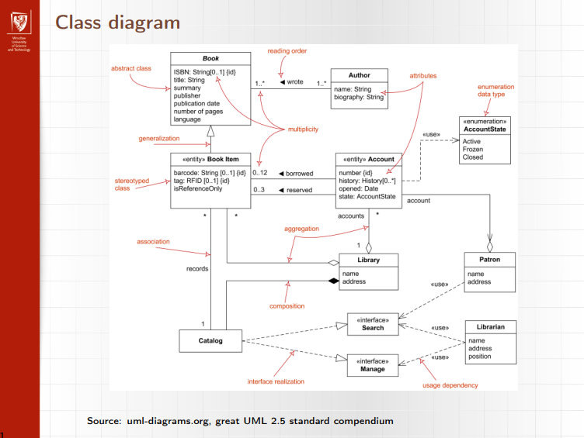
3. Sequence Diagram / Activity Diagram
Activity Diagram
What it models
- Workflows and processes.
- Emphasizes control flow and data flow.
Key concepts
- Actions, object nodes, control nodes.
- Token flow semantics (control tokens vs object tokens).
- Decision / Merge, Fork / Join for branching and parallelism.
- Swimlanes (activity partitions) for responsibility separation.
Best for
- Business processes
- Data-driven workflows
- Parallel execution logic
Source: SE_08.pdf, pp. 9–19

Sequence Diagram
What it models
- Interactions between lifelines over time.
- Emphasizes temporal ordering of messages.
Key elements
- Lifelines (objects, actors, components).
- Messages:
  - Synchronous (blocking)
  - Asynchronous (non-blocking)
  - Return
  - Create / Destroy
- Activation bars (execution specifications).
- Combined fragments: alt, opt, loop, par.
Best for
- Use case realizations
- Interaction protocols
- Scenario modeling
Source: SE_08.pdf, pp. 20–31

4. SOLID
What it models
• Principles for good object-oriented design.
• Focus on maintainability, extensibility, and low coupling.
Key principles
• Single Responsibility (SRP): one class → one reason to change.
• Open/Closed (OCP): open for extension, closed for modification.
• Liskov Substitution (LSP): subtypes must replace base types safely.
• Interface Segregation (ISP): small, client-specific interfaces.
• Dependency Inversion (DIP): depend on abstractions, not concretes.
Best for
• Avoiding god objects and tight coupling
• Improving testability and changeability
• Structuring maintainable OOP systems
Source: SE_12.pdf, pp. 4–5
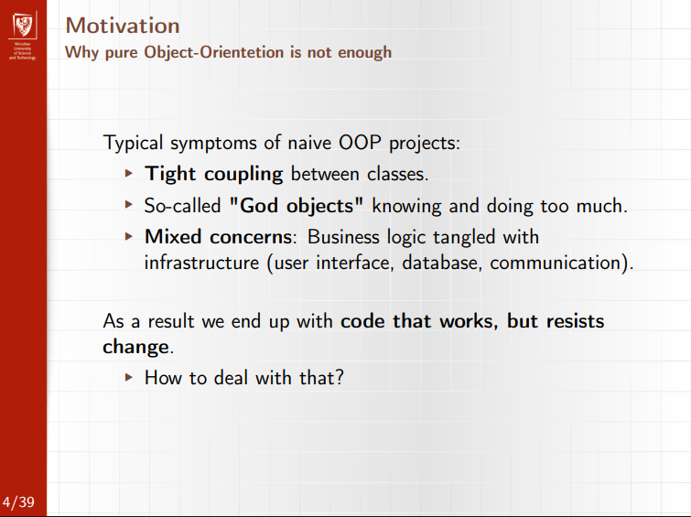
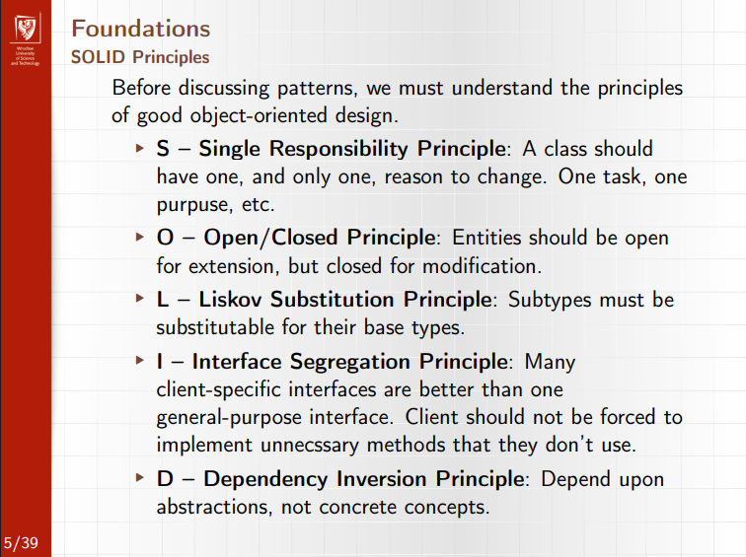
5. C4 Model
What it is
- A lightweight architecture modeling approach by Simon Brown.
- Focused on clarity and different abstraction levels, especially for distributed systems.
Four levels
- Context – system + external actors.
- Container – applications, services, databases.
- Component – internal building blocks of a container.
- Code (Class) – optional, detailed implementation view.
Key characteristics
- Hierarchical abstraction.
- Tool-friendly, less formal than UML.
- Emphasizes communication over completeness.
Source: SE_05.pdf, pp. 34–38
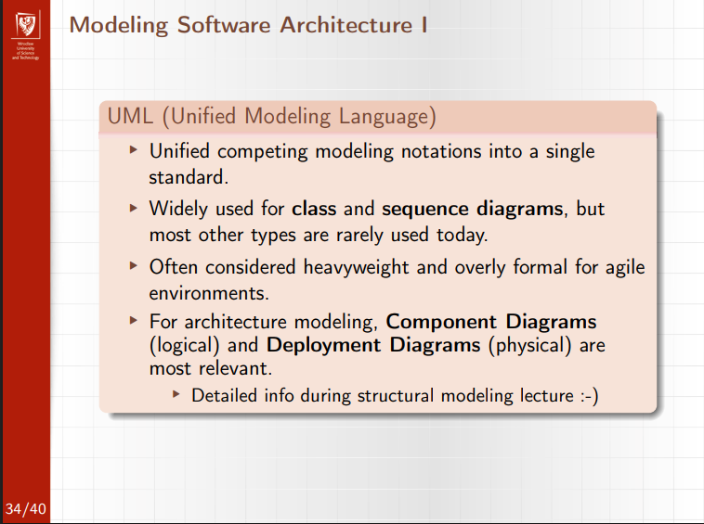
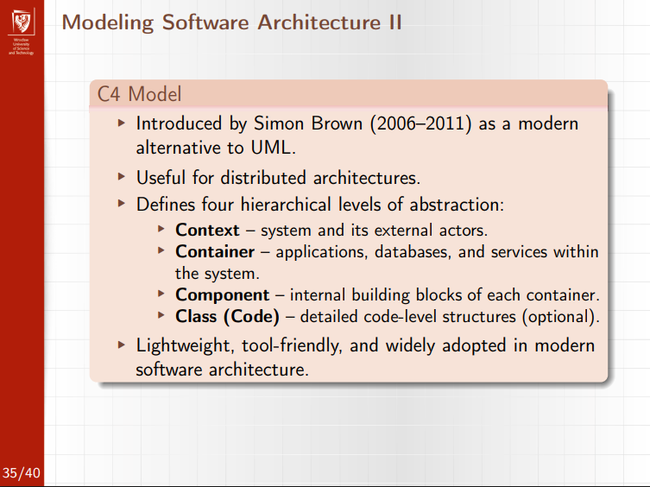
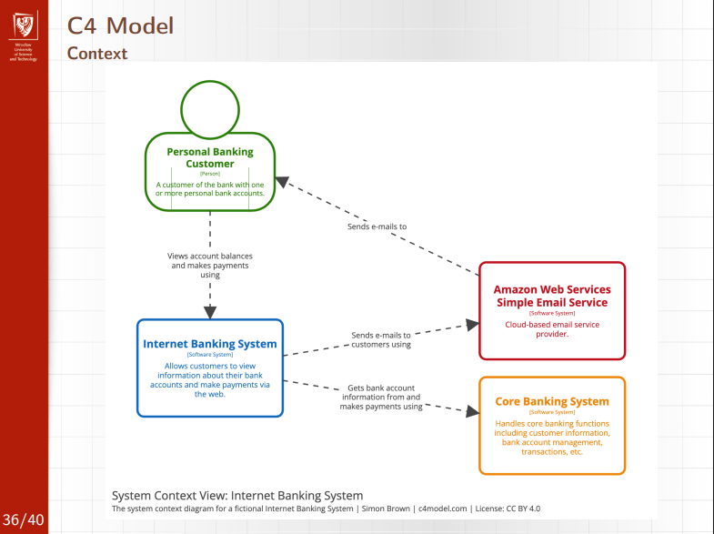
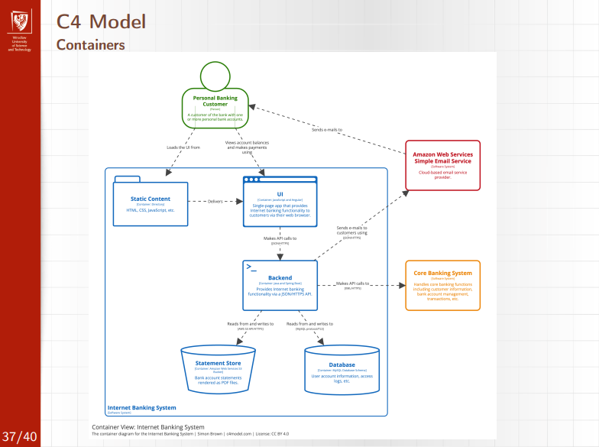
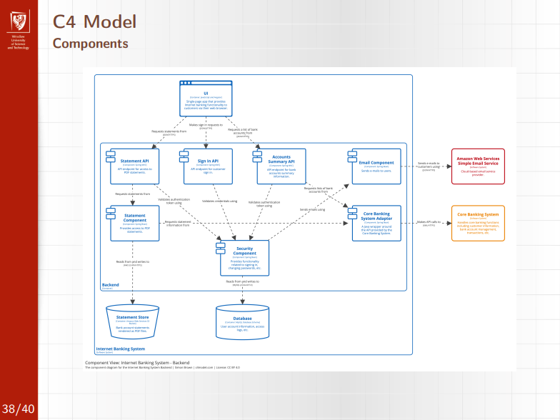
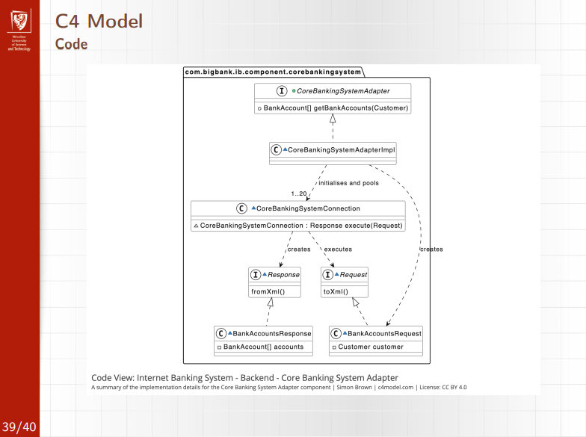

6. DDD (Domain-Driven Design)
What it models
• The core business domain explicitly in code.
• Separation of domain logic from technical concerns.
Key concepts
• Ubiquitous Language: shared vocabulary with domain experts.
• Entity: identity-based object.
• Value Object: immutable, attribute-based.
• Aggregate: consistency boundary.
• Aggregate Root: single access point to an aggregate.
• Bounded Context: explicit boundary where a model applies.
Levels
• Strategic DDD: system structure, bounded contexts.
• Tactical DDD: entities, aggregates, invariants.
Best for
• Complex business domains
• Large systems with multiple models
• Preventing mixed or inconsistent domain logic
Source: SE_12.pdf, pp. 27–31
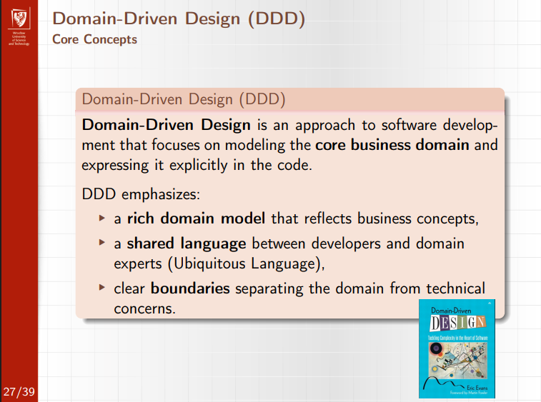
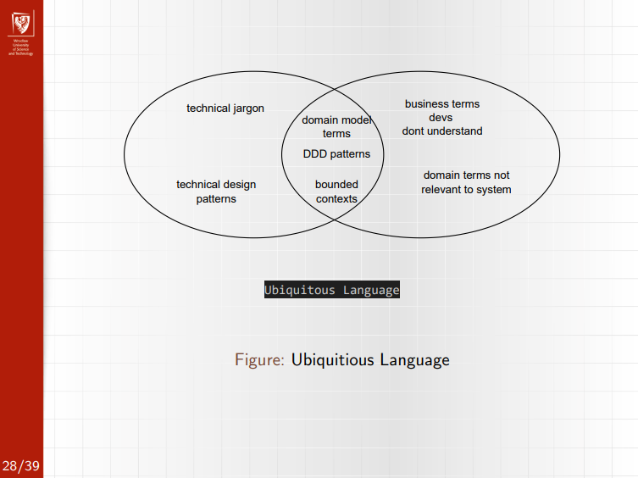
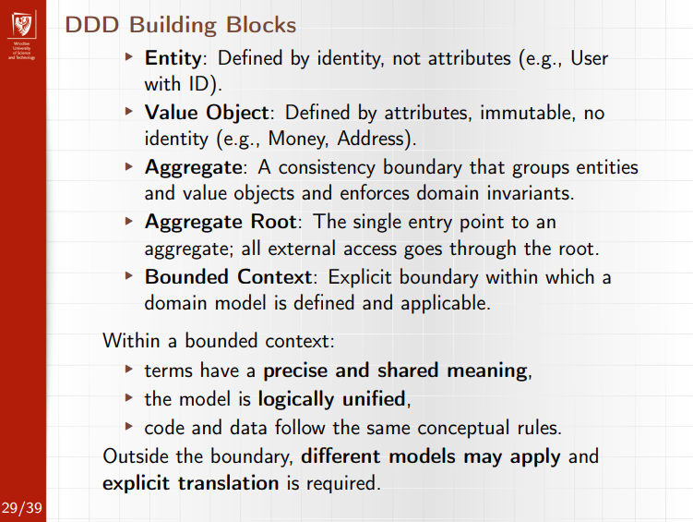
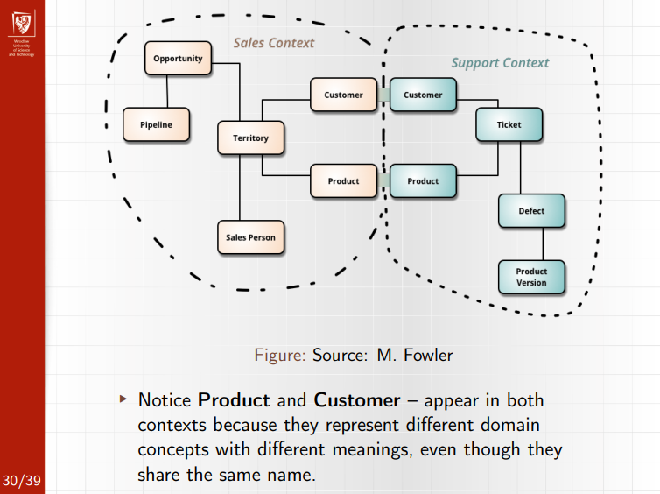
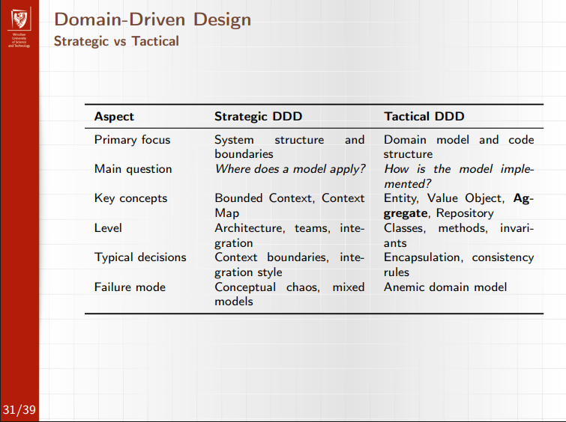
7. GoFDP (Gang of Four Design Patterns)
What it models
• Reusable solutions to recurring design problems.
• Structure and interaction of classes and objects.
Key characteristics
• Context-specific, not copy-paste code.
• Shared vocabulary for design decisions.
• Improves local design quality.
Classification
• Creational: object creation (Singleton, Factory).
• Structural: composition and structure (Adapter, Decorator).
• Behavioral: communication and responsibility (Observer, Strategy).
Limits
• Solve design-level problems, not architecture.
• Do not define system-wide structure.
Best for
• Reducing duplication
• Improving extensibility
• Communicating design intent clearly
Source: SE_12.pdf, pp. 6–9, 23–24
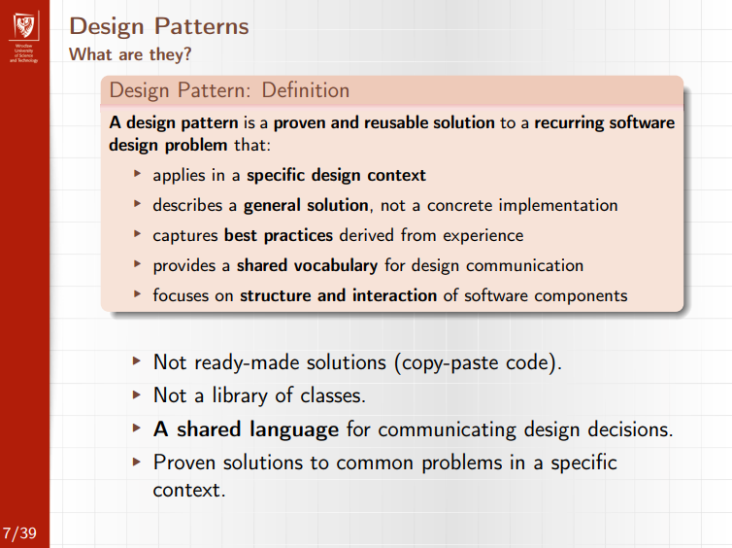
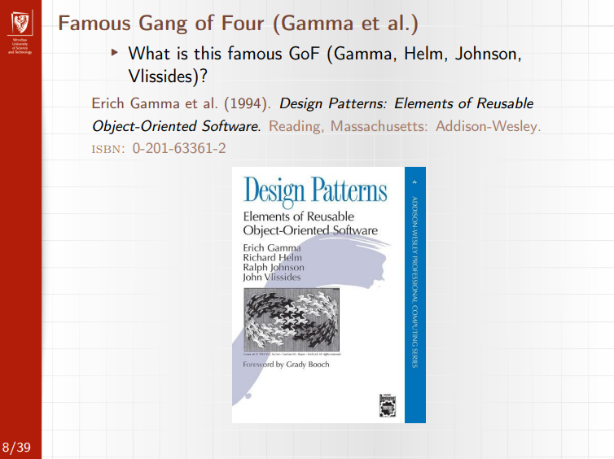
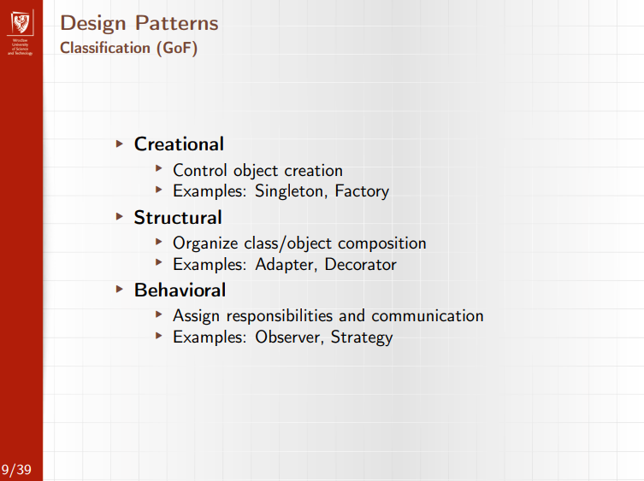
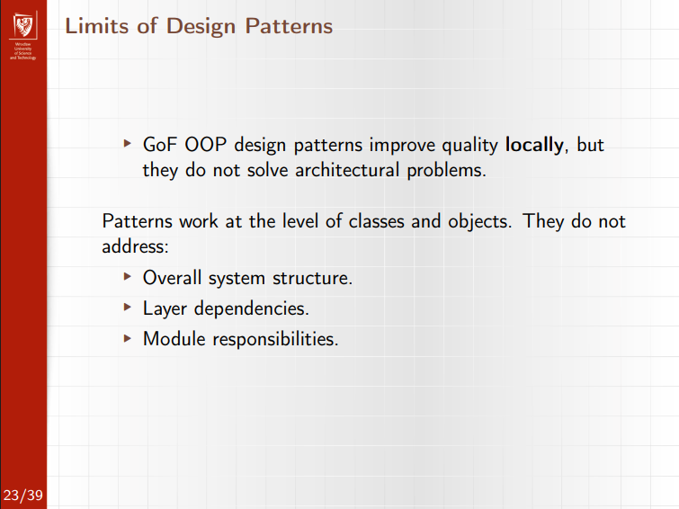
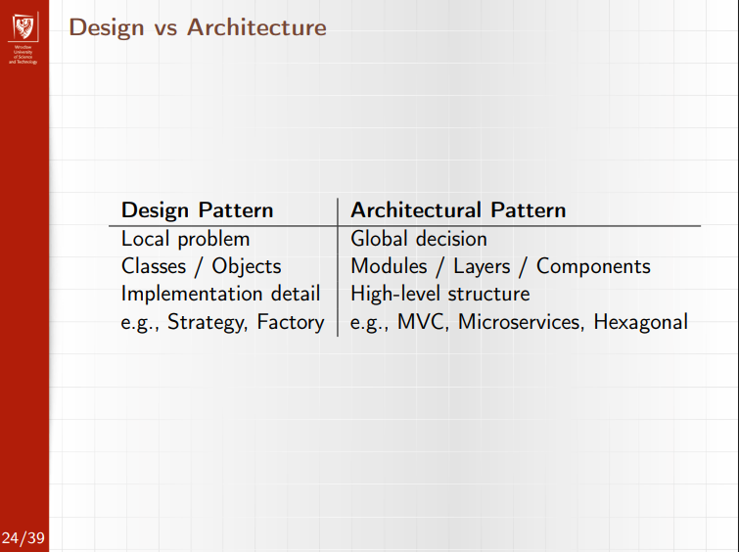
8. Agile Requirements (User Stories)
User stories
- Agile replacement for detailed SRS requirements.
- Format:
As a <role>, I can <action> so that <business value>.
Key properties
- Focus on user value, not technical design.
- Small, testable, and negotiable.
- Stored and prioritized in the Product Backlog.
Related concepts
- Tasks: technical work items derived from a story.
- Spikes: time-boxed research stories to reduce uncertainty.
- Acceptance criteria: define when a story is “done”.
Purpose
- Support iterative development.
- Enable change and continuous feedback.
Source: SE_04.pdf, pp. 18–24
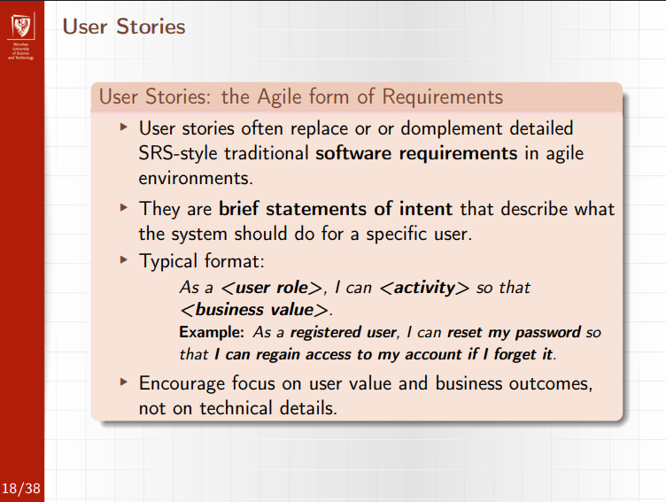
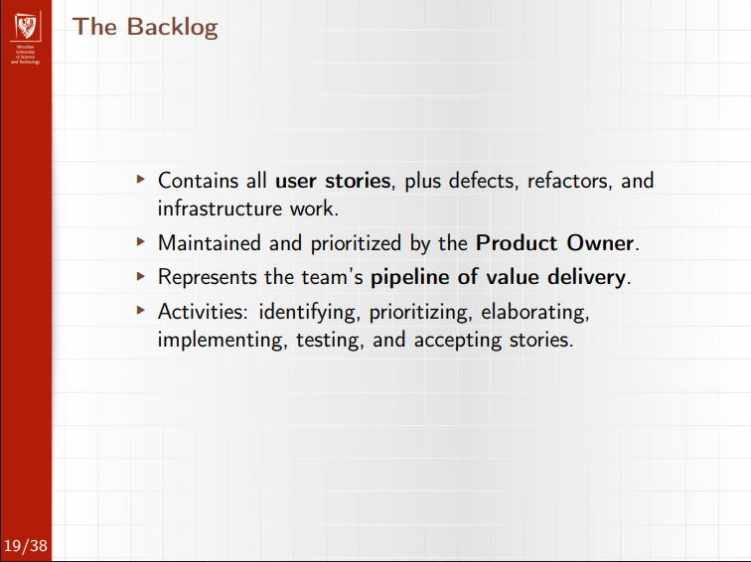
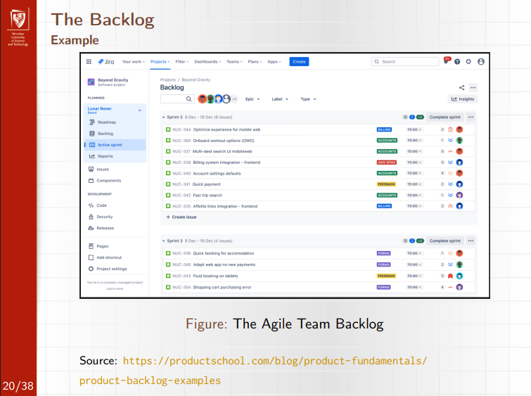
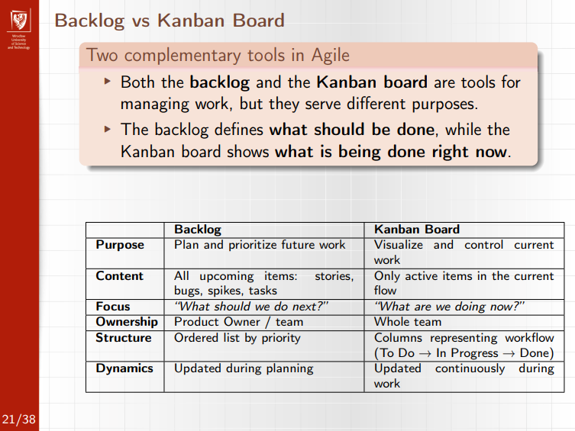
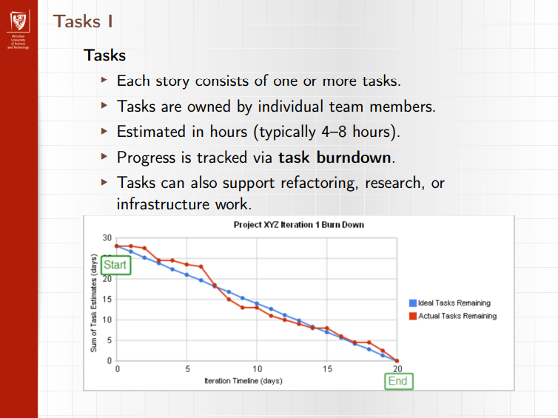
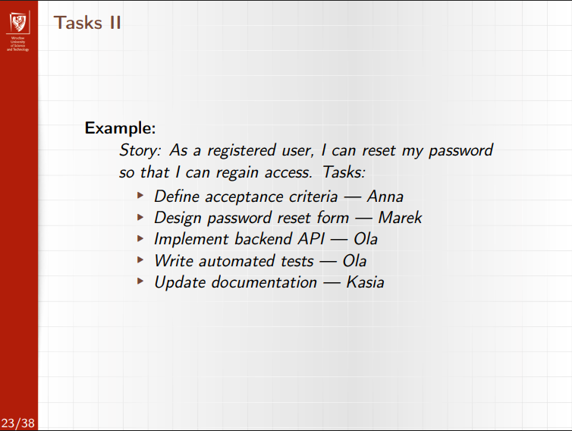
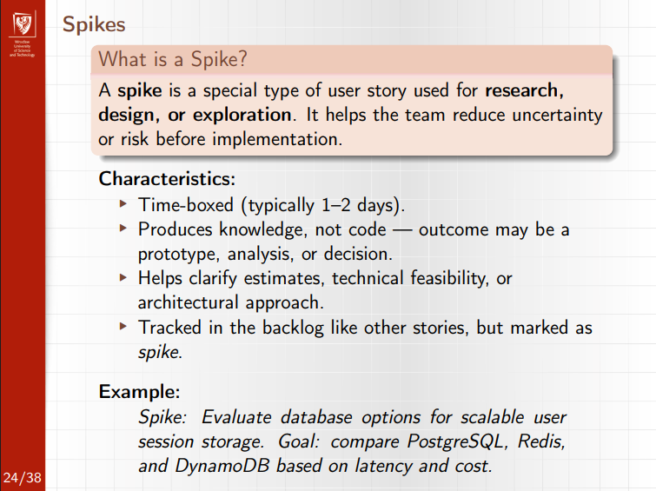
9. Databases
Role in software engineering
- Data outlives applications.
- Data model quality directly affects maintainability, performance, scalability.
Data modeling flow
- Domain model
- Logical model (ER)
- Physical model (SQL / NoSQL)
ER modeling
- Entities, attributes, relationships.
- Cardinalities: 1:1, 1:N, M:N.
- M:N requires associative entity.
- Primary keys (prefer surrogate keys).
- Foreign keys enforce integrity.
Normalization
- 1NF: atomic attributes
- 2NF: no partial dependency
- 3NF: no transitive dependency
- Start normalized, denormalize only for proven performance needs.
SQL vs NoSQL
- SQL: ACID, strong consistency, complex queries.
- NoSQL: scalability, flexible schema, specialized models.
- Types: Document, Key-Value, Column-Family, Graph.
- Polyglot persistence when justified.
Integration
- Repository pattern
- ORM pros/cons
- N+1 problem and solutions
- Schema migrations (Flyway, Liquibase, etc.)
Anti-patterns
- God tables
- Missing foreign keys
- Shared database in microservices
- Premature NoSQL choice
Source: SE_09_10.pdf, pp. 4–46

10. Microservices Architecture
Definition
- Architectural style where an application is built as independently deployable services.
- Each service owns its data and domain logic.
Key characteristics
- Small, business-focused services.
- Independent deployment and scaling.
- Technology heterogeneity.
- Fault isolation.
Communication
- Synchronous: REST, gRPC.
- Asynchronous: messaging, events.
Supporting components
- API Gateway.
- Service discovery/registry.
- Centralized configuration.
Trade-offs
- Pros: scalability, agility, resilience.
- Cons: operational complexity, data consistency, testing difficulty.
Source: SE_05.pdf, pp. 29–31
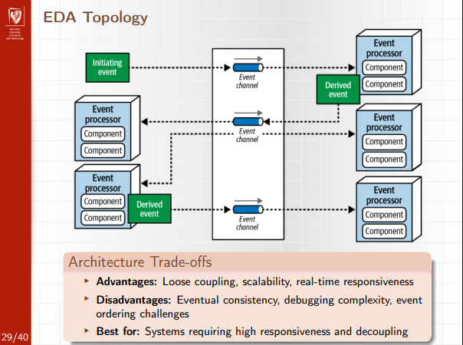
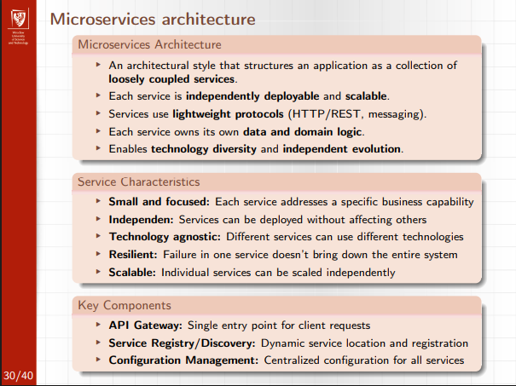
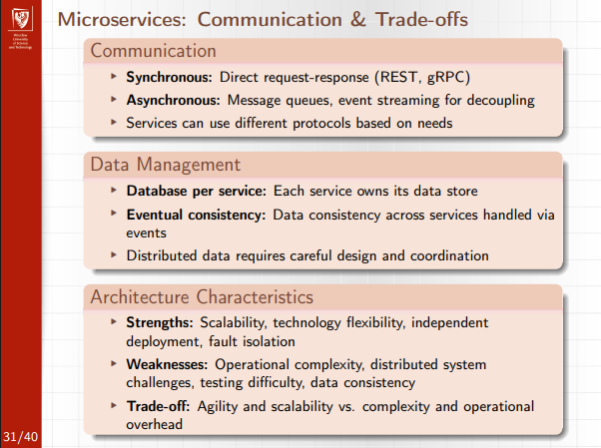
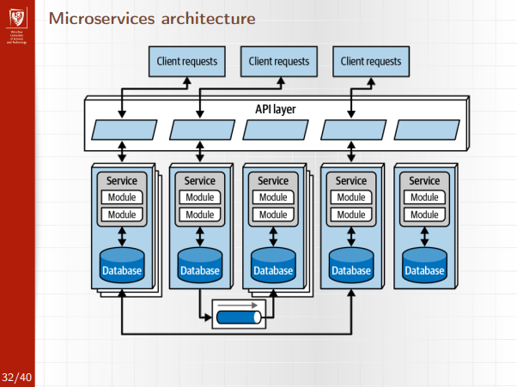

Images from the exam:



